Week 2
Addition activities- Mild
Addition  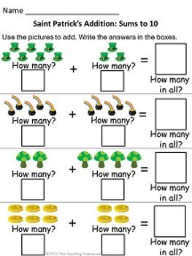  What I am learning:  Add up 2 numbers within 10 using objects or fingers.  Hide one of the piles of objects or one of the set of fingers and imagine them being there to add up. | Number Tower- Card Game  You need one pack of playing cards for1 player, and someone to check the tower.  Choose a NUMBER TOWER to build e.g. 8  Build the tower using pairs of cards that make 8 - look through the cards to find the cards you need.  Players can check they have built their tower correctly by counting  Challenge- Record the number pairs which make the number in your jotter. | - Use a spoon to scoop up 2 spoonful’s of lego bricks or pasta shells. Write down the sums you make in your jotter and how many it is altogether. Can you work out the answer by counting in your head?
- Play snakes and ladders. If you land on a snake or ladder, answer a question correctly to stop you going down and to allow you to go up. You can go up and down snakes and ladders. | - Play the maths games below on a computer.  https://www.starfall.com/h/addsub/add-machine-1/?sn=math1--math0  http://mathszone.net/mw/number/NumberBalance/NumberBalanceGame/index.html level 1 | 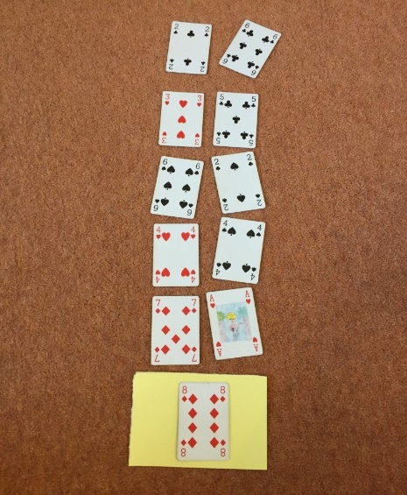

Week 2
Addition activities – Hot
Addition  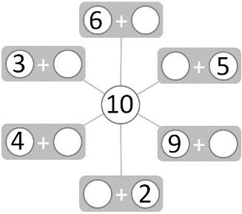  What I am learning:  Fact families within 10. | - Write 0 to 10 out on small pieces of paper and lay them out face down.  - Turn over 2 cards- if they make 10 keep them, if not put them back. | - Take 10 toys and split into 2 different groups each time. Draw them and write the sums you make in your jotter. Can you find 11 different sums?
- Play snakes and ladders. If you land on a snake or ladder, answer a question correctly to stop you going down and to allow you to go up. You can go up and down snakes and ladders. | - Play the maths games below on a computer. Choose 10 for both games.  - http://www.ictgames.com/saveTheWhale/index.html  - https://www.abcya.com/games/fuzz_bugs_number_bonds  - https://www.mathplayground.com/number_bonds_10.html | - Use lego bricks to build explore these number facts  Choose a number between 11-20  Make your number with two different colours  Ask someone in your family to write out the number story for your model i.e 7 + 4 = 11

Addition activities – Spicy
Addition  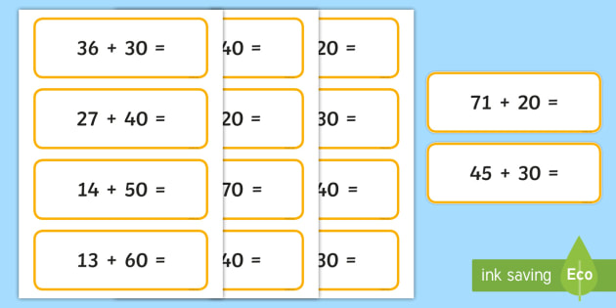  What I am learning:  I can add multiples of ten to a number. | - Work with a partner.  - Write a multiple of ten to make the number sentences true.  5 + ? + ? = 75 ? + 3 + ? = 73  ? + ? + 4 = 84 ? + 7 + ? = 97 | 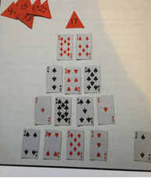
- Play snakes and ladders. If you land on a snake or ladder, answer a question correctly to stop you going down and to allow you to go up. You can go up and down snakes and ladders. | - Play the maths games below on a computer.  - http://www.snappymaths.com/addition/addw10/interactive/addm10imin/addm10immm.htm  - http://www.snappymaths.com/addition/addm10m100/interactive/addm10to2dattack.htm  - http://www.snappymaths.com/addition/addm10m100/interactive/addm10to2d/addm10to2dint.htm | - Pyramid Card Game  Select target number between 10 – 20  Use addition and subtraction to make your pyramid shape with each line totalling the target number. Players place the cards out using 2 cards, then 3 cards, then 4 cards and finally 5 cards

Week 2
Addition activities – Super Spicy
Addition  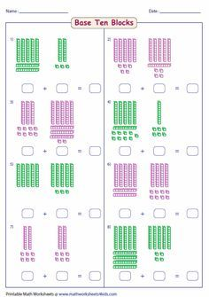  What I am learning:  Add two 2 digit numbers together by splitting the numbers into tens and ones. | - Pyramid Card Game  Select target number between 10 – 20  Use addition and subtraction to make your pyramid shape with each line totalling the target number. Players place the cards out using 2 cards, then 3 cards, then 4 cards and finally 5 cards  Challenge- Include face cards or use for 2x, 5x tables as well. Only use half the pack – this limits the options available | - https://www.ictgames.com/mobilePage/partPartWhole/index.html Use this website tool to make up your own sums and then add them up. Ask an adult to check then write the sums in your jotter. You can make them as tricky as you want – give yourself a challenge!
- Play snakes and ladders. If you land on a snake or ladder, answer a question correctly to stop you going down and to allow you to go up. You can go up and down snakes and ladders. | - Play the maths games below on a computer.  http://www.snappymaths.com/addition/addw100/interactive/addw100imin/addw100immm.htm

