Week 5.
Literacy Activities Mild
Sounds  What I am learning: We are learning the “ph” sound. Please watch Gerldine the Giraffe.  https://www.youtube.com/watch?v=z1bseW0nI2k  Alphablocks also has a good video to watch which also introduces the “ph” sound.  https://www.youtube.com/watch?v=Y810I6Qm9i4 | Ph can be a tricky sound. With an adult can you think of some words featuring the ph sound and draw them in your jotter?  Remember to label your pictures. | Can you practise writing the lowercase r in your jotter?  Watch the first part of this video:  https://www.youtube.com/watch?v=f_GnArgBuwo  Remember to make sure that your letter sits on the line.
Listening Skills  What can you hear?  Can you identify these indoor sounds?  https://www.bbc.co.uk/teach/school-radio/eyfs-listening-skills-inside-sounds/zr2m8xs | 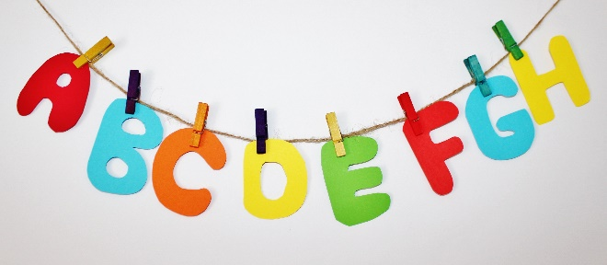 | Log into Giglets to read your assigned book.

Literacy Activities – Hot
Sounds  We are revising the “aw” sound. Please watch Gerldine the Giraffe and Alphablocks.  https://www.youtube.com/watch?v=7xvdbR6g060  https://www.youtube.com/watch?v=YDDkLF1QTXc | Make a list of all the aw words that you can think of.  Can you write some sentences using your aw words?  - The hawk flew high in the sky. | Can you practise writing the capital letter R?  Remember to make sure that your capital letter sits on the line and stretches all the way up to the top.
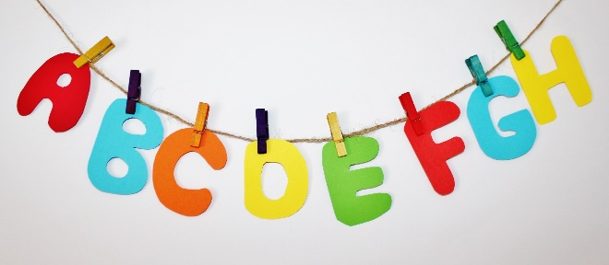 | Comprehension Skills  Download and read the information about the Loch Ness Monster.  Try and answer the questions. The first page is the easiest and the other pages get more challenging. | Reading  Log into Giglets to read your assigned book and complete your task.

Literacy Activities – Spicy
Sounds  We are learning about the th sound  Think of as many words with the th sounds as you can- draw or write them.  Spelling Words: remember to say and hear them before you read or write…  Thin, thick, teeth, froth, thunder, think  Say the word  Hear a partner say the word.  Count the syllables, sounds (r-a-ti-o-n = 5 sounds)  Have a go at writing it.  Can you grow or shrink the words? | Can you find things in your home or garden using your th words?  Write 5 sentences using the things you found.  Can you use a describing word in your sentence?  Remember capital letters and full stops! | Handwriting  Can you practise handwriting these joins-  am, ine, ime, ar, aw  P3- ac, ad, ag, ca, da, ha
 | Comprehension Skills  Download and read the information about the Loch Ness Monster.  Try and answer the questions. The first page is the easiest and the other pages get more challenging. | Reading  Log into Giglets to read your assigned book and complete your task.

