Week 8.
Literacy Activities – Mild
Sounds  This week we are revising the phonics sounds we have already learned.  Please play the literacy games you have been set on Education City. | Can you use your phonics knowledge to build 3 and 4 letter words?  Can you put your words in a sentence?  Can you write the sentence? | Can you practise writing the letter h in your jotter?  Watch:  https://www.youtube.com/watch?v=ImqhKmrXeK4  Remember to make sure that your letter sits on the line.
Talking and Listening Skills  This week on our Google Meet we are going to have another Show and Tell. Think about something you would like to Show and Tell and prepare a small talk on it to share with our friends on Tuesday. | Writing Task  If you have not completed last week’s Health task, please write a short story about which 2 friends in your class you would like to go to a desert Island with and why, and then email it to your teacher. | Log onto Giglets to read the book you have been assigned.

Literacy Activities – Hot
Sounds  We are revising the “ow” sound. Please watch.  https://www.youtube.com/watch?v=Eok_d5ch0OU  Try these activities  https://www.bbc.co.uk/bitesize/topics/zvq9bdm/articles/z64j47h | Please put the following words into a sentence. There are 6 words, please write a sentence for each word.  - Owl  - Brown  - Growl  - Now  - Crown  - Allow | Can you practise writing the capital letter H?  Remember to make sure that your capital letter sits on the line and stretches all the way up to the top.
Talking and Listening Skills  This week on our Google Meet we are going to have another Show and Tell. Think about something you would like to Show and Tell and prepare a small talk on it to share with our friends on Tuesday. | Writing Task  If you have not completed last week’s Health task, please write a short story about which 2 friends in your class you would like to go to a desert Island with and why, and then email it to your teacher. | Log onto Giglets to read the book you have been assigned.

Literacy Activities – Spicy
Sounds- We are learning about ‘qu’  Think of as many words with the ‘qu’ sound as you can- draw or write them.  Spelling Words: remember to say and hear them before you read or write…  Queen, quiet, quilt, equal, quest  Say the word - Hear a partner say the word - Count the syllables and sounds (queen = qu , ee, n = 3 sounds) - Have a go at writing it.  Can you grow or shrink the words? | Write sentences using one of the spelling words in each. Remember capital letters and full stops.  Kung Fu Punctuation  Teach someone in your family kung fu punctuation! Can you use it to read out your sentences?  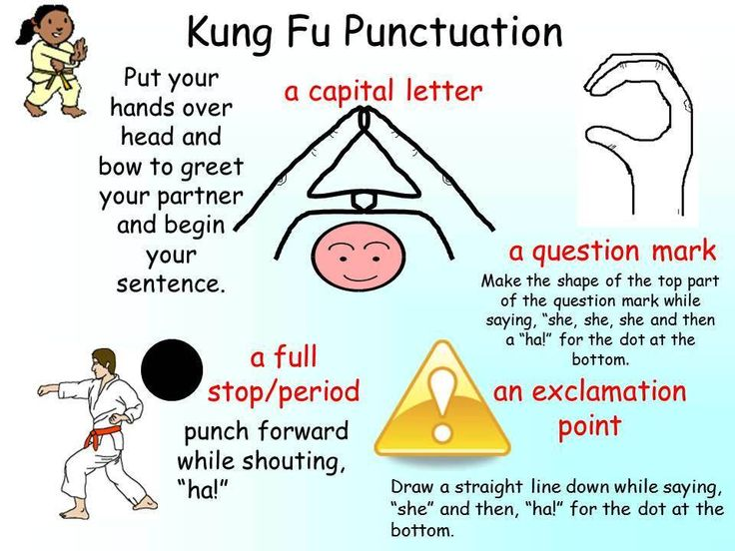 | Handwriting  Practise handwriting these joins- make sure you can form the letters correctly on their own first- we need to write the letter correctly to make joining easier!  Baseline Joins- P2 - ub, th, ck, ch, ent, ant  Joins to anti-clockwise letters and to e P3- ea, ed, ae, be, ce
Talking and Listening Skills  This week on our Google Meet I invite you to share your hobbies and interests with your classmates. You can tell us lots of detail about one thing or share a few activities which interest you. | Writing Task  If you have not completed last week's Health task, please write a short story about which 2 friends in your class you would like to go to a desert Island with and why, and then email it to your teacher.  Thank you to those who have done this already. | Log onto Giglets to read the book you have been assigned.

